HYGENICA CURTAIN GUIDE
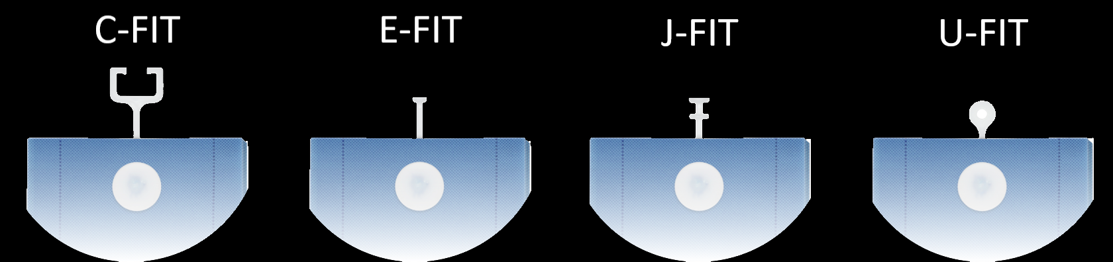
[ CF ] [ EF ] [ JF ] [ UF ]
All curtains come with a standard drop of 2m
 | Range of Sizes
Size |  | Hooks per curtain | Width | Useable Width | Box Quantity
Large  [ LG ] |  | 25 | 7.5m | 5.75m | 5
Standard  [ ST ] |  | 14 | 4.5m | 3.60m | 8
Medium  [ ME ] |  |  | 3.6m | 2.80m | 10
Small  [ SM ] |  | 8 | 2.4m | 1.80m | 15

[ MB ] = MEDICAL BLUE
All the codes in [ ] are in our SKU
for example CF-ST-MB-2000

C-FIT Standard Medical Blue
[ LB ] = LIGHT BLUE
[ LI ] = LILAC
[ GY ] = GREY
[ MG ] = MEDICAL GREEN
[ CR ] = CREAM
[ WH ] = WHITE

