M SAFETY DATA SHEETT
PRODUCT SAFETY REPORT
According to REGULATION EC 1272/2008 (CLP)
& Regulation EC 1223/2009 & 1907/2006/EC, Article 31
PRODUCT NAME: MEDIKILLS-19 Wipes
1. IDENTIFICATION OF THE FORMULATION
Product name |  | MEDIKILLS-19 Wipes
Classification |  | An aqueous mixture of active ingredient, solvents and preservative.
Chemical name |  | N/A (complex mixture)
Supplier & Emergency information |  | DYNAMIC 9 Ha Te'ena street, Small Industrial Zone, Nir Galim, ASHDOD, ISRAEL,  Tel: 972-8-852-3377, Fax: 972-8-852-1818  email: yaron@dynamicwipes.com  Emergency: 972-52-258-4951 – Yaron
Last revision |  | October 2nd, 2020
2. HAZARD IDENTIFICATION
Hazard Class: |  | Not a hazardous composition
Signal Word: |  | N/A
Category: |  | N/A
Hazard description |  | N/A
Intended Use |  | Surface disinfectant Biocide Type PT2 according BPR BIOCIDAL PRODUCT REGULATION EU 528/2012
P-Codes |  | P102: Keep out of reach of children
Emergency Overview |  | Not expected when used according to instructions
Routes of Entry |  | Skin contact, possible eye contact – no hazard expected
Potential Acute Health effects: No acute health hazard
Eyes |  | This product may cause slight reversible eye irritation
Skin |  | No effect is expected on healthy skin
Inhalation |  | Not an expected route of entry.
ingestion |  | Not an expected route of entry. Ingestion may cause temporary nausea, dizziness, gastrointestinal irritation
3. COMPOSITION OF PRODUCT
Chemical characterization |  | N / A (mixture)
Description |  | Mixture of substances listed below with nonhazardous ingredients.
Content of Heavy metals in packaging materials  (Directive 94/62/EG) |  | The concentration of the following metals: Pb, Cd, Hg, Cr⁺⁶ (Hexavalent) is: (less than) < 50 ppm.
Presence of PAHs |  | The product does not contain any Polycyclic aromatic hydrocarbons
Type of detergent: |  | No detergents present
Dangerous components |  | SOLVENT:    CAS: 64-17-5: (0.1%≥)  INCI: Ethyl Alcohol  Hazard Class: Flammable Liquid cat. 2  Eye irritation cat. 2A  Signal word: Danger  H-codes: H225 H319
SOLVENT:
CAS: 107-21-1.
INCI: Monoethylene Glycol (0.1%≥).
Hazard Class: STOT, RE, Oral, cat. 2,
Acute Toxicity, Oral cat. 4 (Liver)
Signal word: Warning
H-codes: H302 H373
DISINFECTANT: CAS: 7173-51-5.
INCI: Didecyldimethylammonium Chloride (0.03%).
Hazard Class: Skin Corrosion, cat. 1B
Acute Toxicity, cat. 4
Signal word: Danger
H-codes: H302 H314
DISINFECTANT: CAS: 63449-41-2.
INCI: Benzalkonium Chloride (0.03%).
Hazard Class: Skin Corrosion, cat. 1B
Acute Toxicity, Oral cat. 4
Acute toxicity, Dermal, cat. 4 Acute Aquatic Hazard, cat. 1

Signal word: Danger

H-codes: H302+H312 H314 H400
DISINFECTANT:
CAS: 27083-27-8.
INCI: Polyhexamethylene Biguanide Hydrochloride (PHMB) (0.013%).
Hazard Class: Eye Damage, cat. 1
Acute Toxicity, Inhalation cat. 3
Carcinogenic, cat. 2 STOT, RE, cat. 1
Skin Sensitization, cat. 1
Signal word: Danger
H-codes: H331 H351 H372 H318 H317
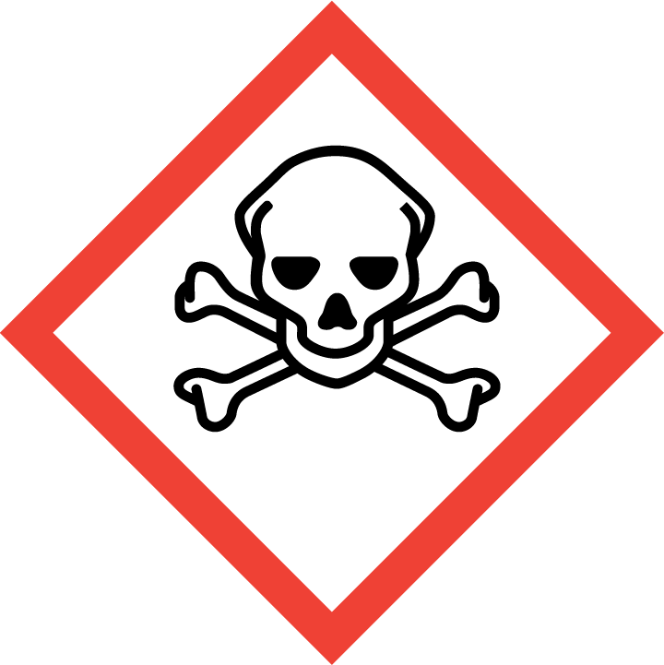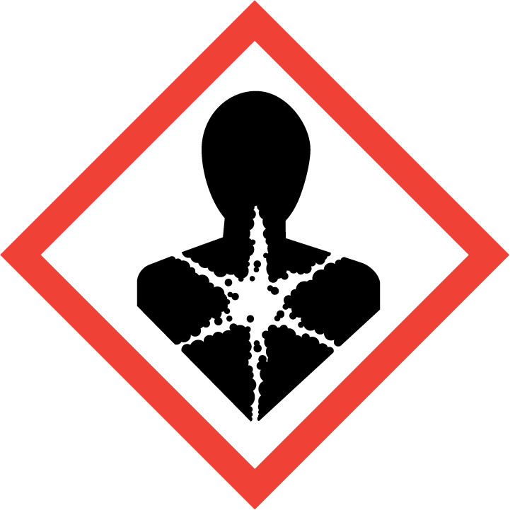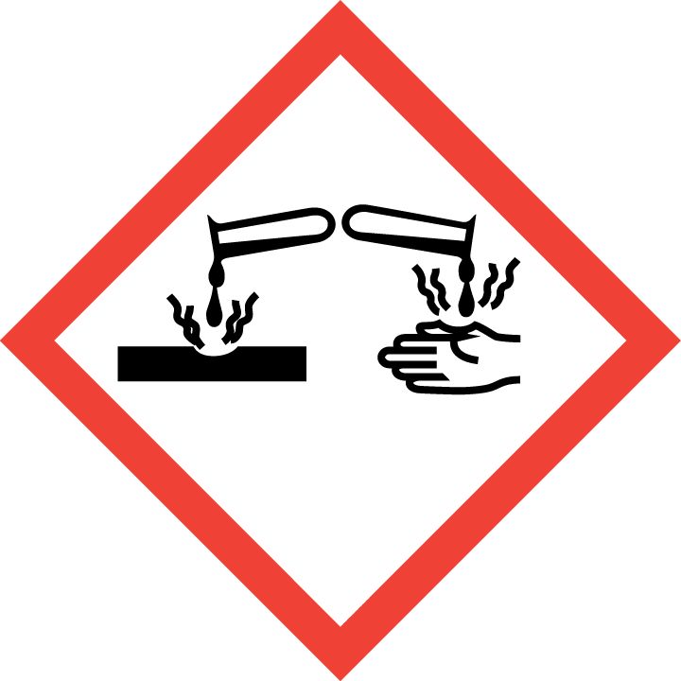

PRESERVATIVE:
CAS: 59-50-7.
INCI: p-Chloro-m-Cresol (0.001%).
Hazard Class: Acute toxicity oral cat. 4,
Acute toxicity dermal cat.4,
Serious eye damage cat.1,
Skin sensitization cat. 1,
Acute Aquatic Hazard, cat.1.
Signal word: Danger

H-codes:
H302 + H312 H317 H318 H400
PRESERVATIVE:
CAS: 52-51-7:
INCI: 2-Bromo-2 Nitro-1, 3-propanediol
(Bronopol) ( max. 180 ppm)
Hazard Class: Acute toxicity oral cat. 4,
Acute toxicity dermal cat.4,
Eye damage cat.1,
STOT SE Respiratory cat. 3,
Chronic Aquatic Hazard cat. 2
Acute Aquatic Hazard, cat.1.
Signal word: Danger
H-codes:
H302 + H312 H318 H315 H335 H400 H411
Ingredients of the perfume that need to be declared on the label according to Regulation of European Parliament Council 2003/15/EC
The product does not contain any perfume ingredients to declare
Wording of the H-codes for the above components:
H225 | Highly flammable liquid & vapor |  | H302 | Harmful if swallowed
H312 | Harmful in contact with skin |  | H314 | Causes severe skin burns and eye damage
H315 | Causes skin irritation |  | H317 | May cause an allergic skin reaction
H318 | Causes serious eye damage |  | H319 | Causes serious eye irritation
H335 | May cause respiratory irritation |  | H351 | Suspected of causing cancer
H373 | May cause damage to organs (Kidney) through prolonged or repeated exposure if swallowed
H400 | Very toxic to aquatic life |  | H411 | Toxic to aquatic life with long lasting effects

4. FIRST AID MEASURES
After skin contact | In the unlikely event of irritation wash with plenty of water, and temporarily discontinue use of the material.
After eye contact | Wash under running water for at least 15 minutes. Consult a doctor if irritation persists.
After inhalation | Unlikely to cause any problem.
After ingestion | Do NOT induce vomiting. Rinse mouth well with water and offer some milk.

5. FIRE-FIGHTING MEASURES
Extinguishing media | Water solution: Liquid is not combustible.
Unsuitable extinguishing media | Not known.
Unusual firefighting hazard | Not known.
Special firefighting procedure | Not required.
Protective equipment | No special measures required.
Combustion products | Not combustible. Package may release unknown gasses.

6. ACCIDENTAL RELEASE MEASURES
Personal precaution | Avoid eye or prolonged skin contact. During production use eye goggles, protective gloves and polymer apron.
Precaution to protect the environment | See “cleanup procedure”. Do not allow to enter sewers/ surface or ground water.
Cleanup procedure | No special measures are necessary for the wipes. If during production the liquid is spilled absorb it with a suitable absorbent (sand, diatomite, universal binders, or sawdust). Dispose of in the proper method defined by local authorities.

7. HANDLING & STORAGE
Handling:
Information for safe handling | No special measures required.
Information about fire - and explosion protection | No special measures required.
Storage:
Requirements to be met by storerooms and receptacles | No special requirements. Avoid high temperatures.
Information about storage in one common storage facility | Not required. No cross-interaction expected.
Other information | Not known.

8. EXPOSURE CONTROL AND PERSONAL PROTECTION
Exposure control | Avoid eye contact. Avoid unnecessary skin contact (with the liquid during production only).
Exposure limit for hazardous ingredient | No exposure limit for the finished product
Personal protective equipment:
Respiratory | Respiratory equipment not required.
Hand | Use protective gloves (only for the liquid production stage).
Eye | Use safety goggles (only for the liquid production stage).
Skin | Use a proper outfit that covers the body and hands (only for the liquid production stage).
Industrial hygiene | Exercise good industrial hygiene practice.  Wash after handling, keep away from food.
Other information | Not known
Ingredients with limit values that require monitoring at the workplace: N/A

9. PHYSICAL & CHEMICAL PROPERTIES (of the liquid absorbed on wipe)
Physical form | Transparent thin liquid
Odor | specific
Color: | No color
Solubility in / Miscibility with water | Miscible in all proportions
Density | 1.00 ± 0.05 | 20º /C
Flash point | ≥ 158º F (70º C) | P.M. closed cup
pH | 7.5 ± 0.50 | 10% solution in water
Volatile Organic Content | practically 0% | V.O.C.

10. STABILITY AND REACTIVITY
Stability in the original unopened container | Stable under ambient conditions. Shelf life exceeds 24 months.
Reactivity:
Thermal decomposition / conditions to be avoided | No decomposition if used according to specifications.
Dangerous reactions | No dangerous reactions known. DO NOT mix with any other ingredients or products.
Dangerous decomposition products | No dangerous decomposition products known.

11. TOXICOLOGICAL INFORMATION
Acute toxicity: | Oral ATE > 2,000 mg/kg bw; Dermal ATE > 2,000 mg/kg bw; Inhalation ATE(vapour) > 20 mg/L.  Conclusion: NOT CLASSIFIED.  All ATEs were determined in accordance with the calculation method for ingredients as described in regulation (EC) No 1272/2008
Skin corrosion / irritation | NOT CLASSIFIED.
Serious eye damage/irritation | NOT CLASSIFIED.
Respiratory or Skin Sensitization | NOT CLASSIFIED.
Additional toxicological information (Germ Cell mutagenicity, Carcinogenicity, Reproductive Toxicity, STOT-SE, STOT-RE, Aspiration Hazard) | The product is not subject to classification according to the CLP regulation. When used and handled according to specifications, the product does not have any harmful effects to our experience and the information provided to us.

12. ENVIRONMENTAL (ECOTOXICOLOGICAL) INFORMATION
Environmental fate and distribution:
General notes: | Not classified for acute toxicity or chronic aquatic toxicity according to the calculation method as described in Regulation (EC) No 1272/2008. No data is available for the product
Air | No damage to the atmosphere expected.
Water | The liquid is soluble in water but the mode of use of the wipes minimizes the effect on the municipal sewage system.
Terrestrial Environment | Low mobility in soil expected and no relevant components present at levels of concern
Bioaccumulative potential | No components present in relevant amounts which are considered persistent
Persistence and degradation | No components present in relevant amounts which are considered persistent
BOD & COD | Not determined.
Degradation | Most ingredients (over 99.5%) are biodegradable.

13. DISPOSAL CONSIDERATIONS
Product  Recommendation | Smaller quantities can be disposed of with household waste. Prevent the disposal of large quantities (during production only) to the sewer systems.
Un-cleaned packaging  Recommendation | Disposal of industrial quantities must be made according to official local regulations.
Recommended cleansing agents | Water.

14. TRANSPORT INFORMATION
Road & rail transport | Not subject to ADR & RID regulations
Sea transport | Not subject to IMDG code
Air transport | Not regulated by ICAO/IATA.

15. REGULATORY INFORMATION
Prepared according to 1907/2006/EC, Article 31, and Regulation (EC) No 1272/2008 (CLP / GHS) and According to ISRAELI STANDARD 2302 parts 1&2
The product is intended as a surface disinfectant Biocide Type PT2 according BPR BIOCIDAL PRODUCT REGULATION EU 528/2012

16. OTHER INFORMATION
All the information supplied in this data sheet is based on the current knowledge available to DYNAMIC at the time of revision. For further information or clarification of data and any relevant information available on the product and the safety of handling it, please contact DYNAMIC directly. However, we make no warranty of merchantability or any other warranty, express or implied, with respect to such information, and we assume no liability resulting from its use. Users should make their own investigations to determine the suitability of the information for their particular purposes. In no way shall DYNAMIC be liable for any claims, losses, or damages of any third party or for lost profits or any special, indirect, incidental, consequential or exemplary damages, howsoever arising, even if the company has been advised of the possibility of such damages.

